Poopify Manual Test Plan

When you launch the app, the home screen should look similar to the image below.

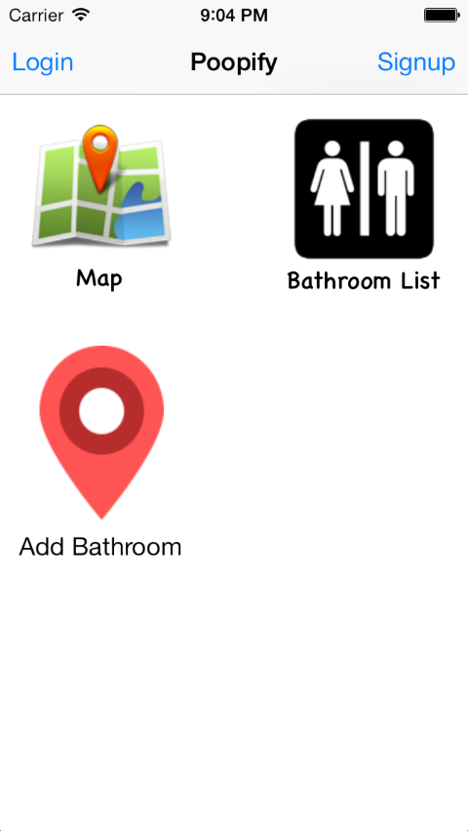

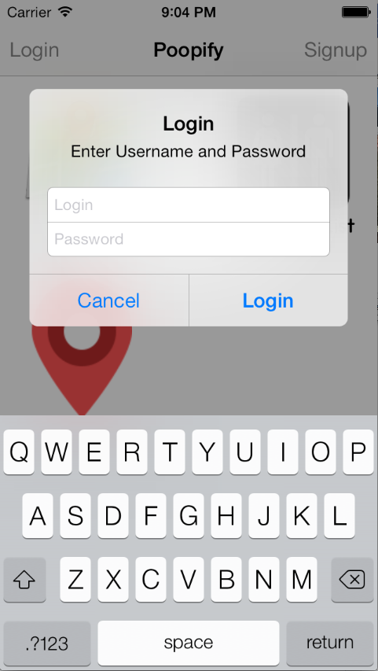When you click the login button at the top left, the page should look like this.

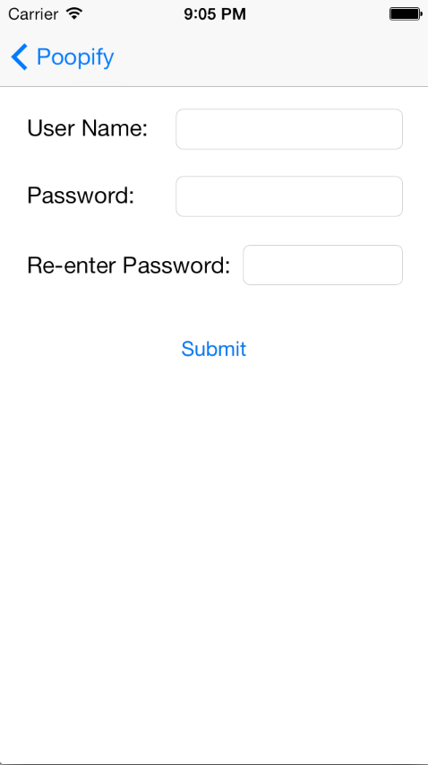When you click signup in the top right, the page should swipe in from the right and look like this.

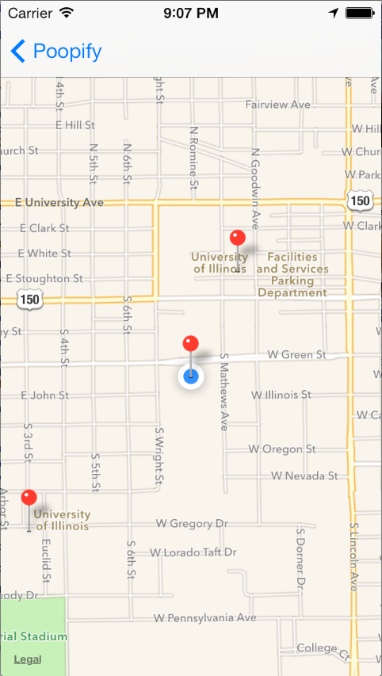When you click the map button it should open a page that looks like the image below.

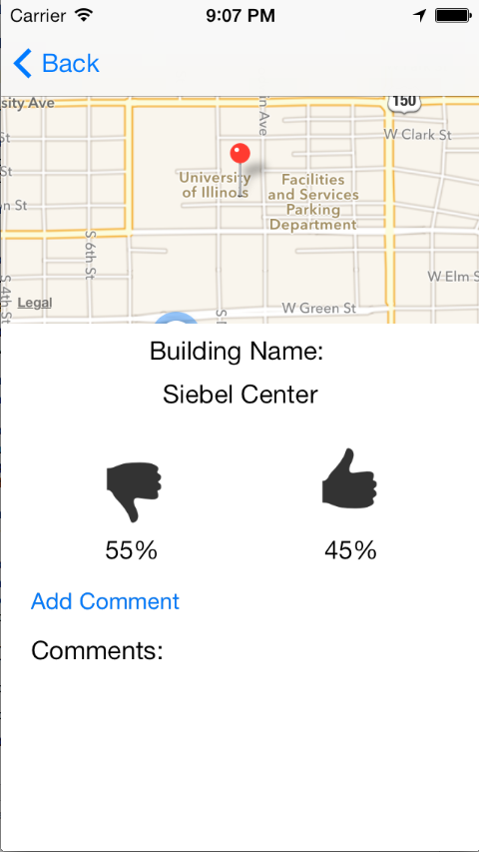If you click on one of the pins and select the information button, it should open a page that looks like this.

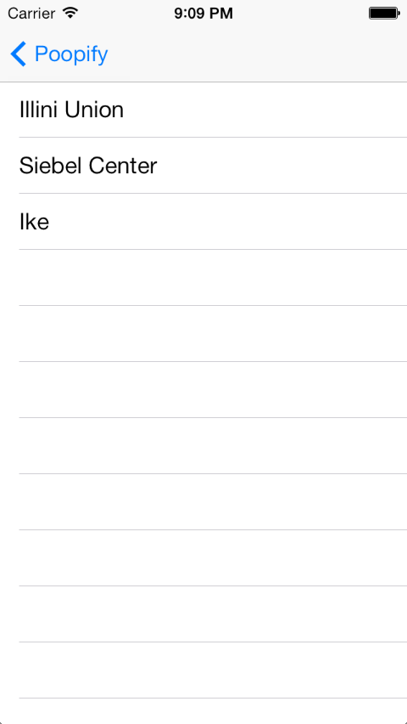When you clock on bathroom list on the main page, it should open a page that looks like this. And if you click on one of the names, it should open a page that looks like the picture above this.

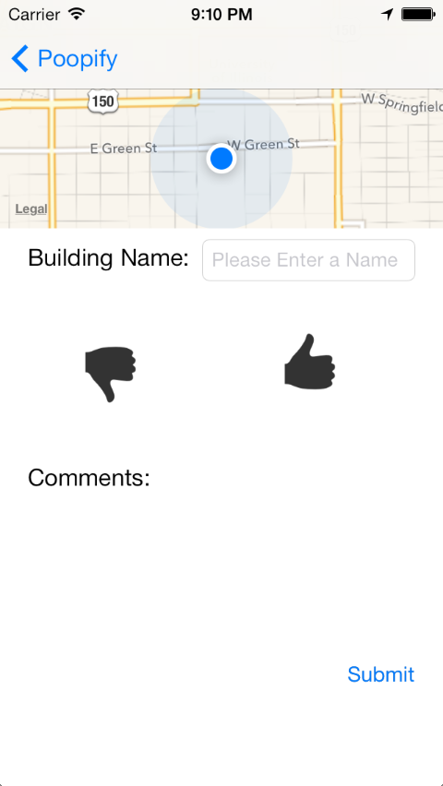When you press the Add Bathroom button on the front page, it should open up a screen that looks like this.

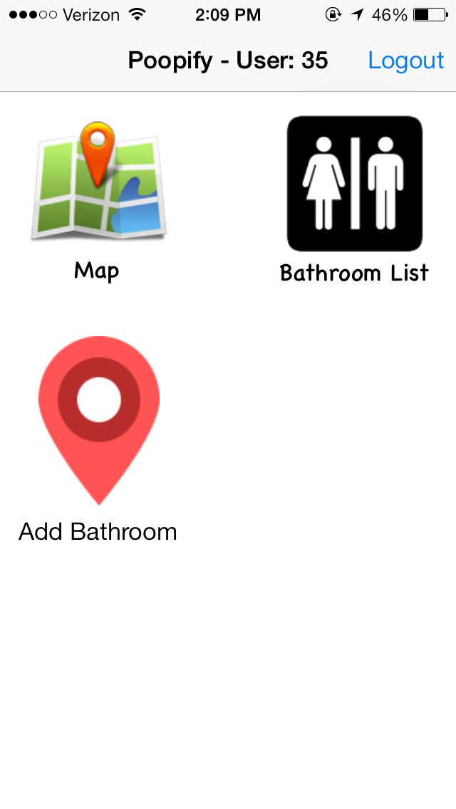When you login, the home page should look similar to the picture below. The User: (#) will be different based on your account.

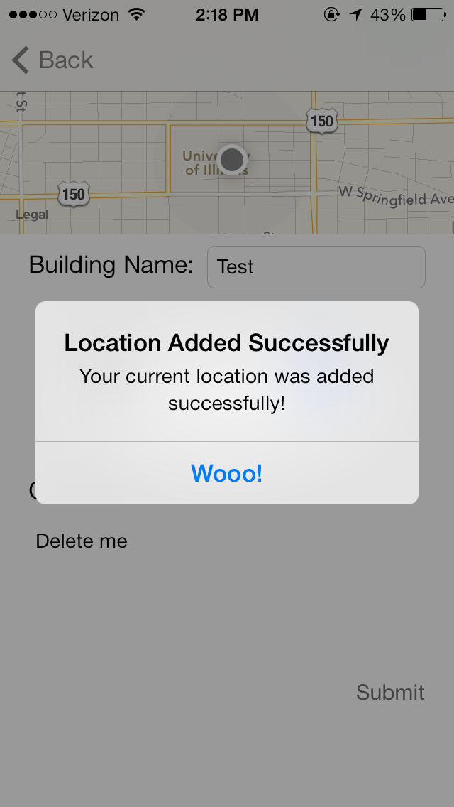When you add a location, fill in all the information and click submit, you should get a popup that looks like the following.

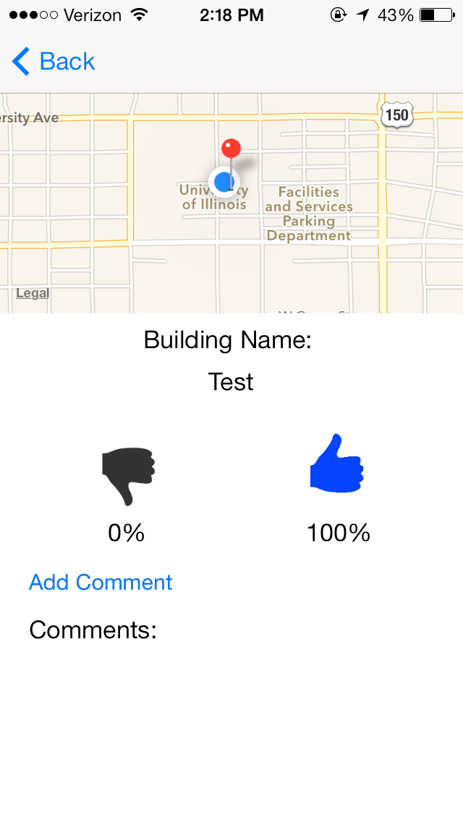When you open up a location you have already rates, the thumb that you rated should highlight as in the picture below. If you change your rating, it should change the selected thumb and change the percentages to reflect the new values as in the second image.

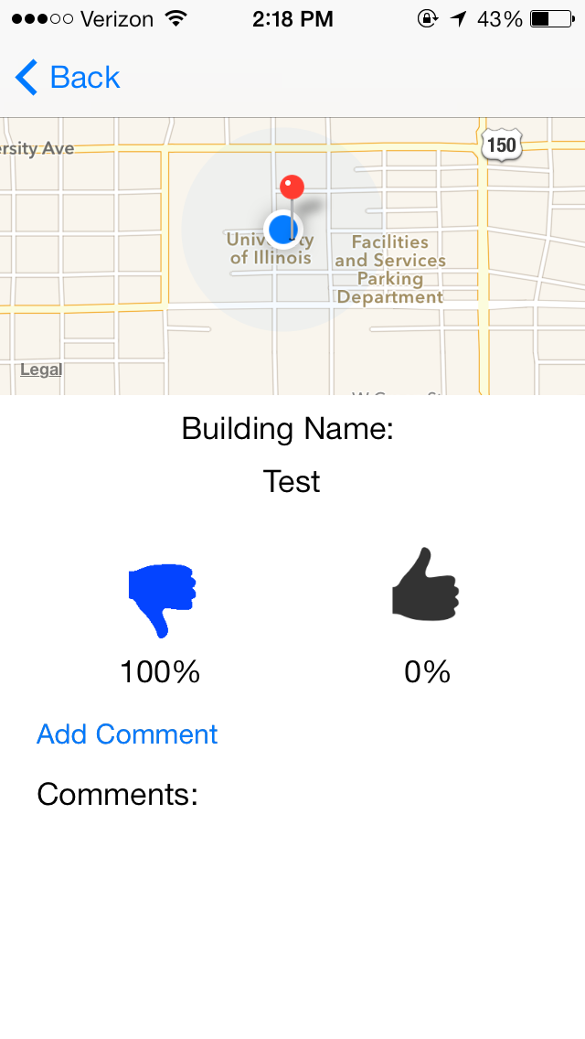

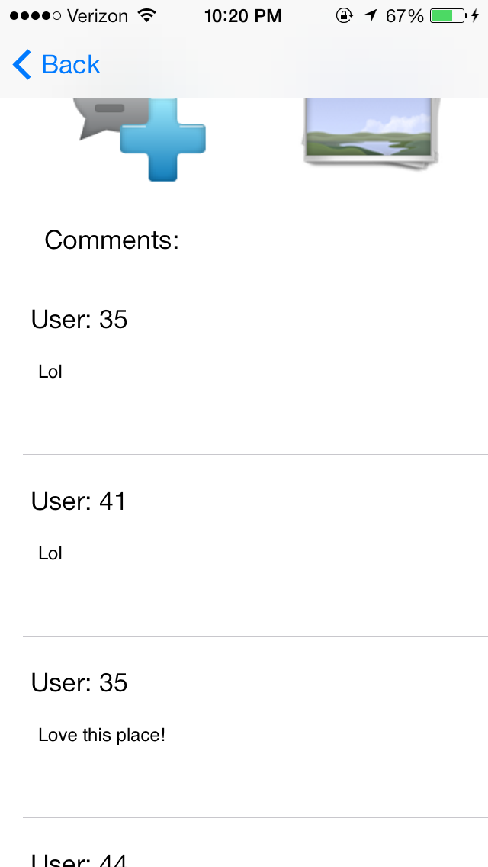When you load a page, either from the map view or list view, it should look like this. Notice the comments should be there at the bottom of the page, if comments exist, and there is a new image button.

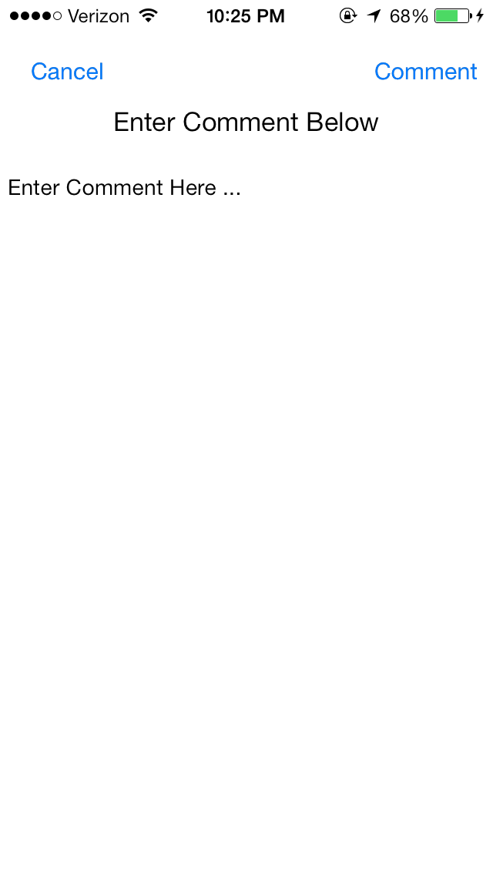When you click the add comment button it should bring you to a page that looks like this. When you click comment it should bring you back to the previous page and your comment should now appear at the bottom!

When you click the photo button, it should take you to a page that looks like the one below. It may have more or less (none) pictures on it. When you click the plus in the top right, it should take you to the camera like the second picture. After you take the picture and choose to use it, it will take you back to screen one and you picture should appear at the bottom of the list of pictures

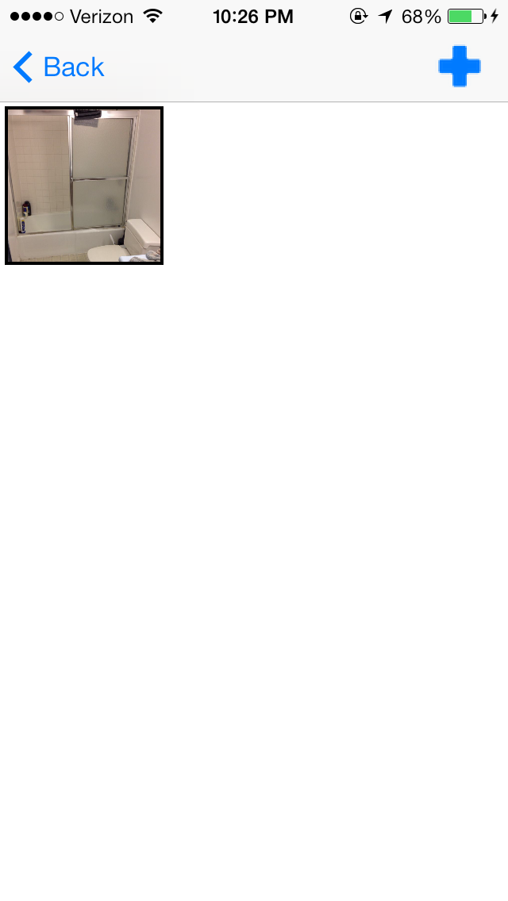

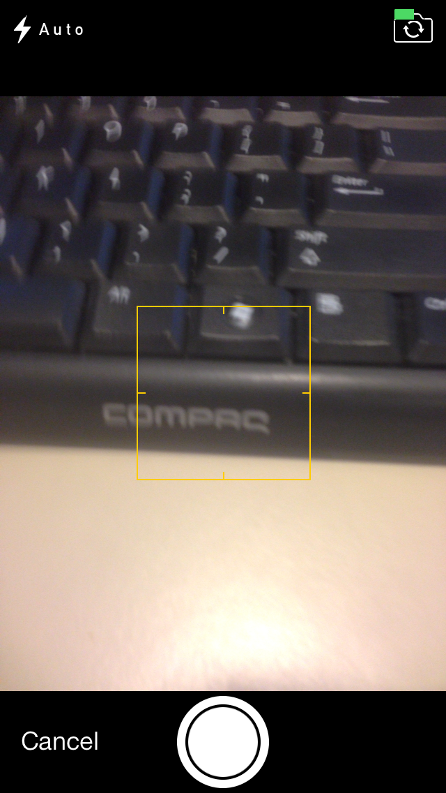

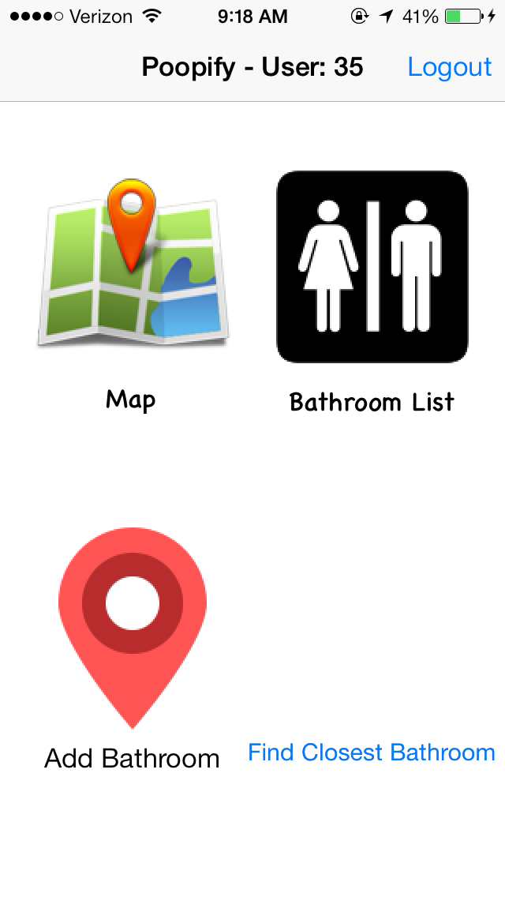Now when you open the home screen, there should be another button and it should look like this.

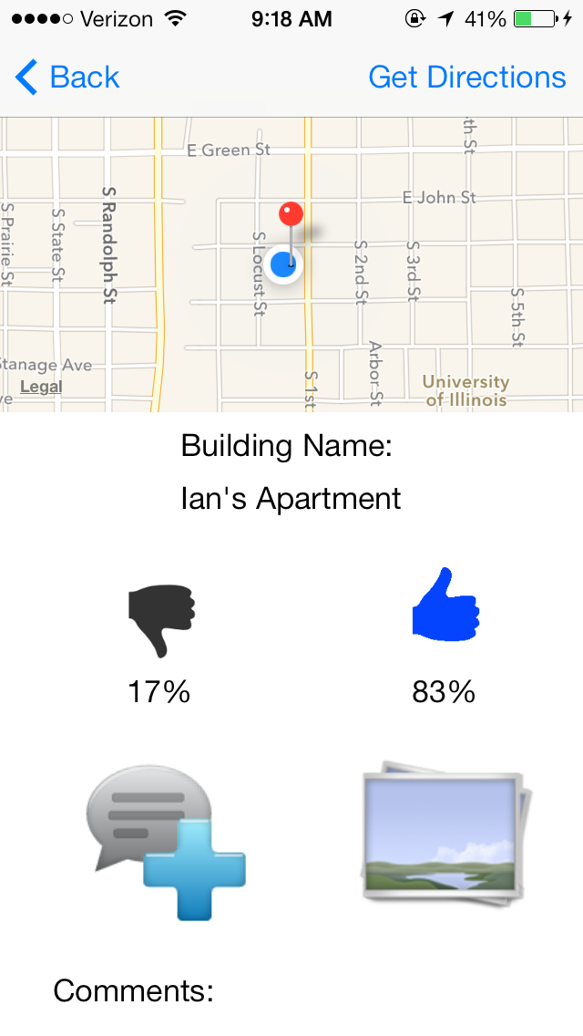When you click on “Find Closest Bathroom” there should be a loading page and then it should display a bathroom like normal. It should look like the page below.

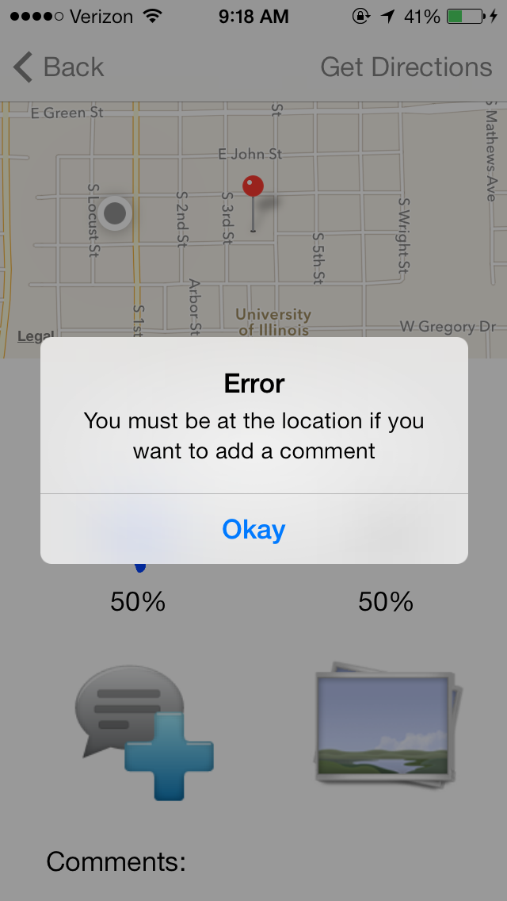Now you can click the button in the top right that says “Get Directions” and it will open Google Maps and give you directions to the bathroom. If you are not actually at the bathroom location you cannot add comments or pictures. If you try you will see the following alerts.

